- Once the Offer is sent to Buyer , the Buyer will login to the session Enquiry in Process .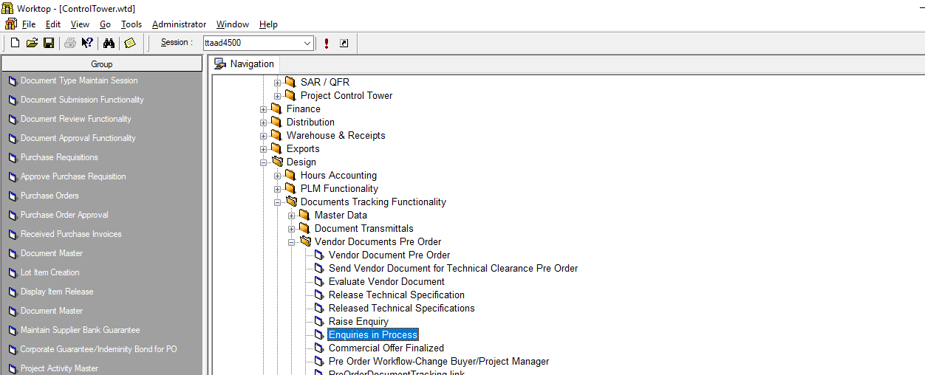
Select Session

- Select View Enquiry in the screen that opens up.
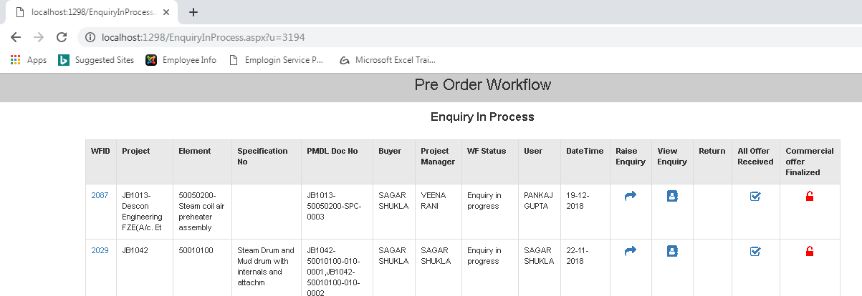
Select View Enquiry
- Click on WFID against that Enquiry
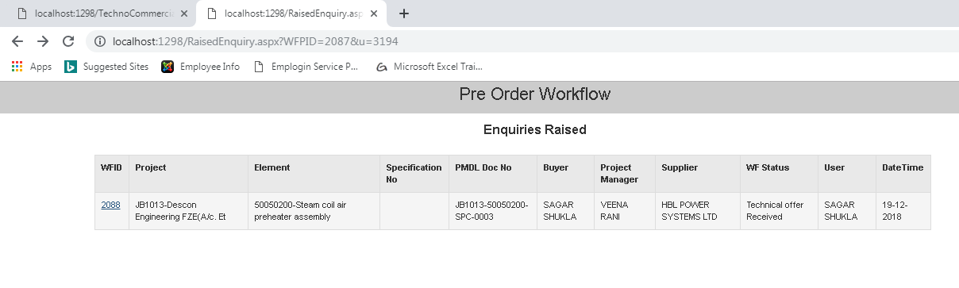
Select WFID

- In the screen that opens up click on Technical Offer Received Button
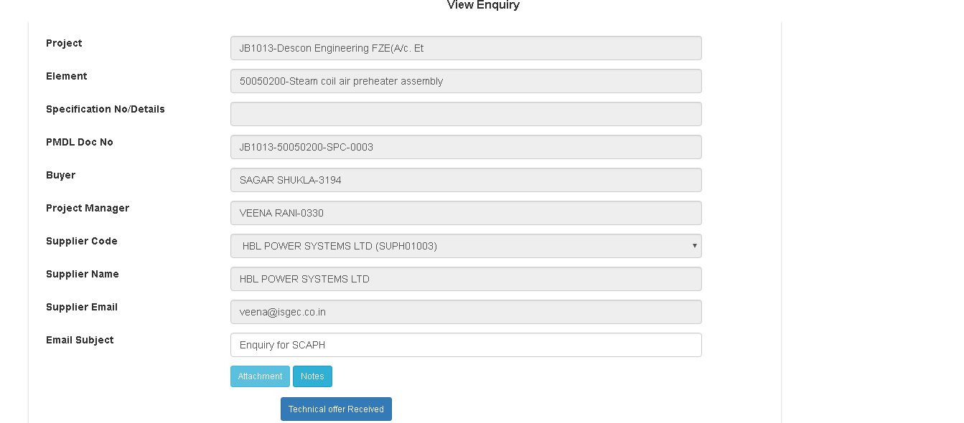
Technical Offer Received
- In The Screen that Open up the Status will change to Technical Offer Received.
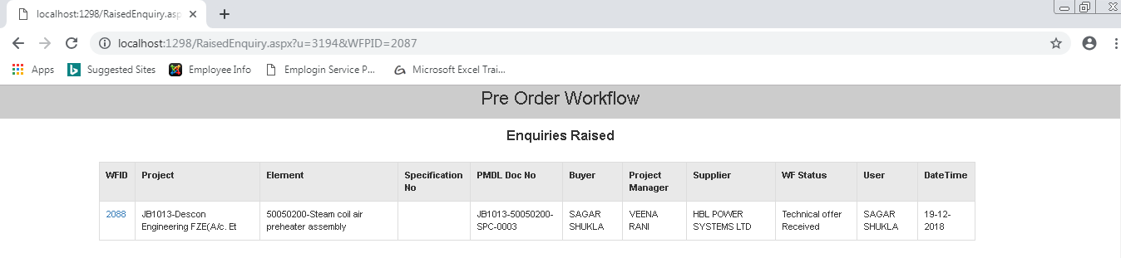
Status Changed

- Click on WFID.
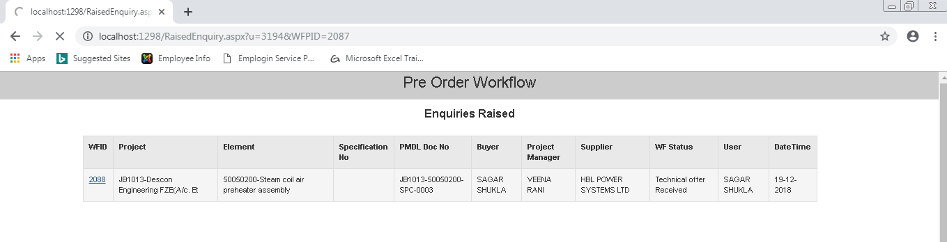
Click Here

- Click on IDMS receipt
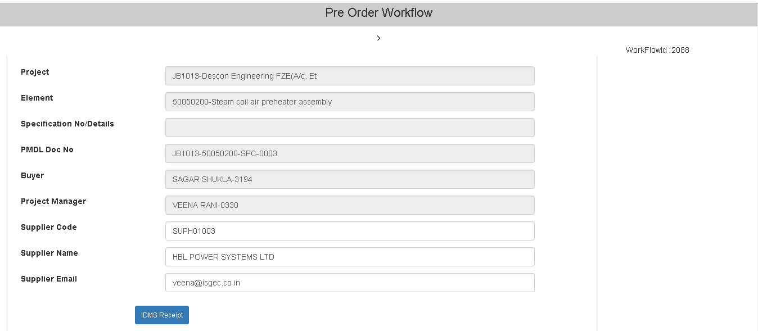
Click on IDMS Receipt

- The following screen will open up with populated data as shown.
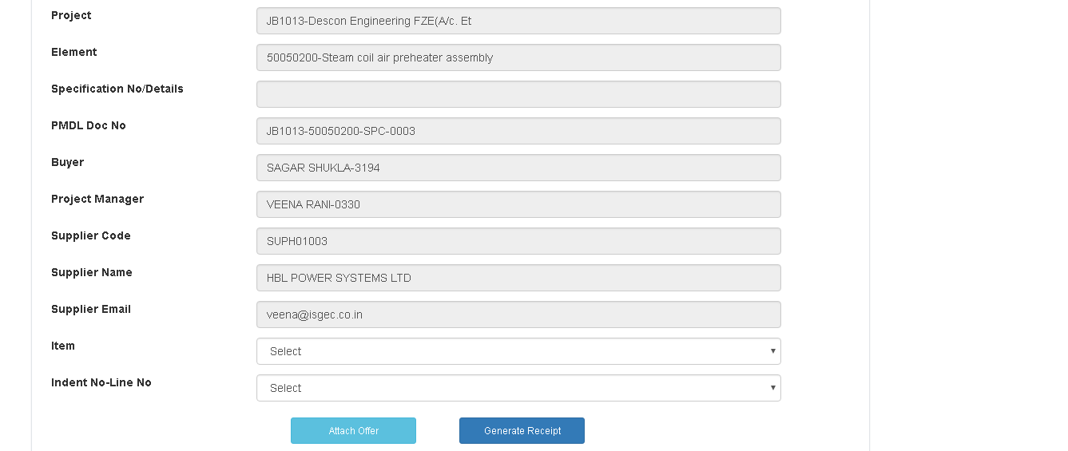
Click on IDMS
Receipt

- Select Item (Mandatory) & Indent No- Line No ( Not Mandatory), Then Click on Attach Offer .
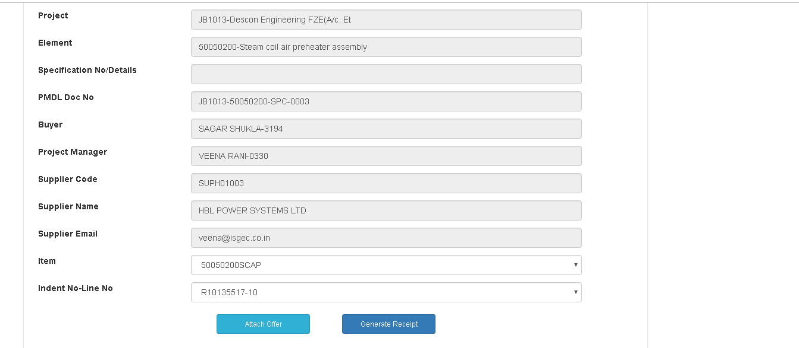
Not Mandatory
Mandatory
Attach Offer

- Click the Note in which the Offer is attached by the vendor, then click on Attach Offer.

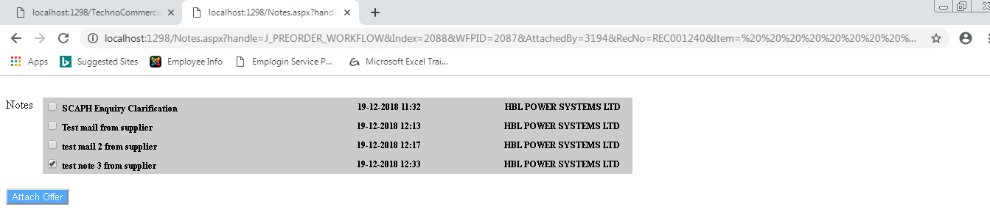
Attach Offer

- Click on Generate Receipt.
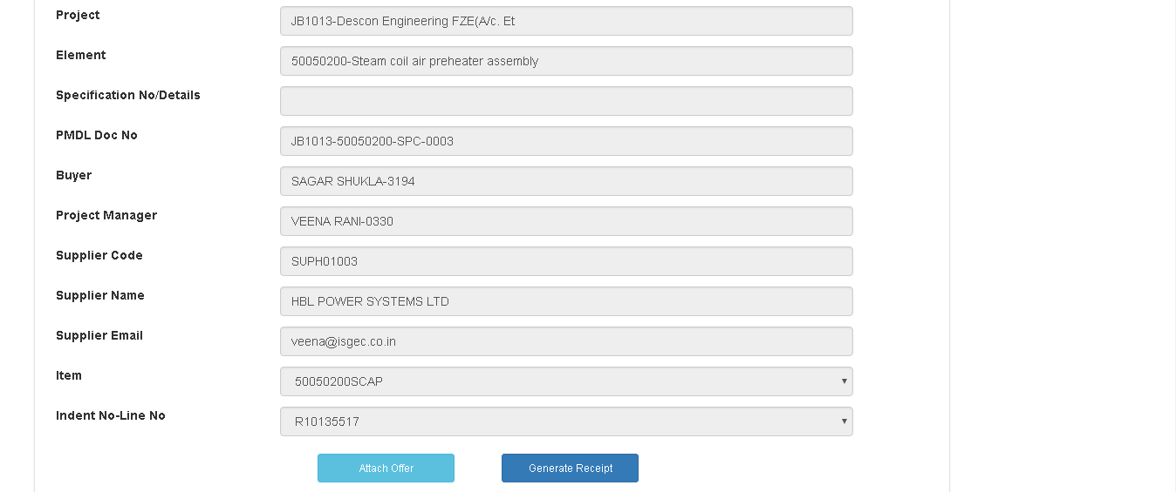
Generate Receipt

- Receipt No Will Be generated & attachment will appear in the screen that opens up.
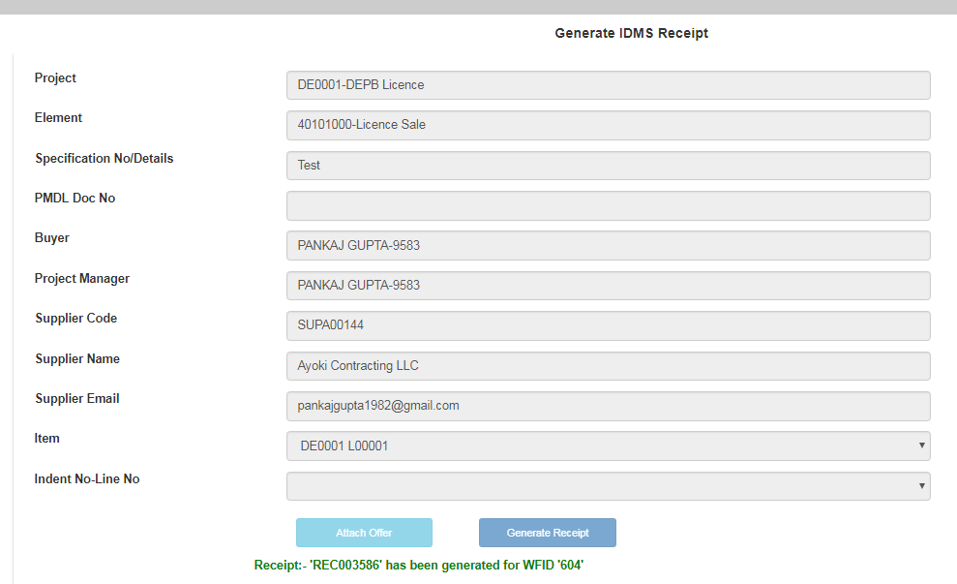
Receipt No will be generated

- E Mail Alert will go to Respective Engineering Person .( Pl Ensure that the “LOT Code wise responsibility Master for Pre Order”,” Employeewise Responsible Department” & “Engineering Function wise Employee Master” is Maintained for that Project in ERP IDMS module otherwise the E mail Alert will not Go To Engineering). If LOT Code wise responsibility master for Pre Order is not maintained then buyer will have to forward it to Engineering.

